Context Diagram

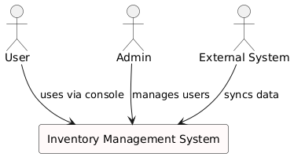

@startuml

!define RECTANGLE class

skinparam rectangle {

BackgroundColor Snow

BorderColor Black

}

actor User

actor Admin

actor "External System" as ExternalSystem

rectangle "Inventory Management System" as IMS {

}

User --> IMS : uses via console

Admin --> IMS : manages users

ExternalSystem --> IMS : syncs data

@enduml